Yanco Public School Little Learners
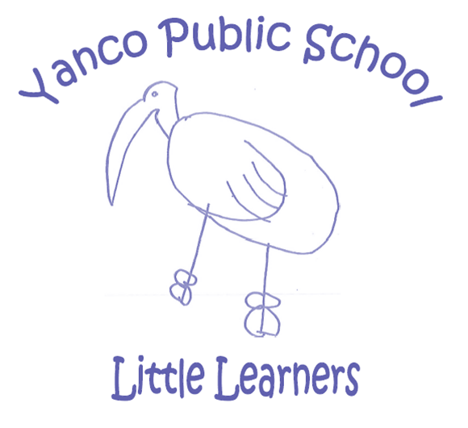
ENROLMENT POLICY

Yanco Public School is running Little Learners, a free, year-long transition program for 3 – 5 year olds. The program’s vision is for all children to experience play-based learning that is engaging, provides a positive transition experience into school and builds success for life.
The Little Learners program aims to ensure that children receive a high quality experience and will provide them with the skills to succeed at school. It is designed to help familiarise both parent/carer and child with the school environment so that future enrolments are both confident and happy at our school. The opportunity also enables potential new students and parents to develop positive relationships with members of the school community.
Yanco Public School’s Little Learners program is aimed at children from 3 to 5 years of age in the year before they will commence their formal education in Kindergarten. Each session will run from 9.30 am- 12.00 pm every Friday, from Week 5 of Term 1 to Week 5 of Term 4.
Children will be in the care of an experienced teacher, with the support of a School Learning Support Officer. The adult to child ratio will be 1:10.
All applications for enrolments must be received at the start of the year the child wishes to enrol, (regardless of when they turn 3) to ensure the application is considered. Students will then be offered a placement using the criteria below. Placements will then be offered using the criteria below and confirmation will be received by telephone call from staff. Please note that spots are never guaranteed until this confirmation is received. For those not three at the start of the year and on the waiting list, confirmation must be obtained after their birthday to ensure there is a current vacancy.
Priority for enrolment will be as follows;
- Children who intend to enrol at Yanco Public School the year after the transition program.
- Children who intend to enrol at Yanco Public School the second year after the transition program.
- Children who intend to enrol at a public school within the Leeton Community of Public Schools after the transition program.
- Children who intend to enrol at a catholic or independent school after the transition program.

Due to the popularity of our Little Learners program students who will be attending Yanco Public School must be given priority. To adhere to the staff student ratio, students not planning to attend Yanco Public School will be placed on a waiting list and their place is not assured until confirmation is received from the office.
NOTE: Enrolment of Students in Government Schools
Children may enrol in Kindergarten at the beginning of the school year if they turn five years of age on or before 31 July in that year. Documentation providing proof of age, such as a birth certificate or passport, is required on enrolment. The enrolment of eligible children in the Kindergarten year is to commence within the first week of the school year.

